**GROUP #17**

**THE SQUAD**



**PROJECT PHASE 1**

**DATABASE INITIAL STUDY**

**(CMPG 311)**

**Group Members:**

[35821663 – O.R.B Ntlhe] – (Group Leader)

[37612034 – N Khunoane]

[35427795 – O Sebolai]

[31228208 – M.K Kondile]

[32756356 – O Lethoba]

Submission Date: 07/04/2023

***Table Of Contents***

**Project Phase 1 – Database Initial Study..........................3**

Members of the group 4

Analyse company situation 5

Define problems and constraints 8

Database system specification 8

Conceptual Design 11

I. Business rules 12

II. ER Diagram 12

Logical Design 11

1. Database Objects 12

I. Tables 13

II. Indexes 13

III. Views 13

IV. Data loading 13

2. Queries 12

I. Limitation of rows and columns 12

II. Sorting 12

III. LIKE, AND and OR 12

IV. Variables and character functions 12

V. Round and/or trunc 12

VI. Date functions 12

VII. Aggregate functions 12

VIII. Group by and having 12

IX. Joins 12

X. Sub-queries 12

Project Phase 1 – Database Initial Study

# Members of the group



Oarabile Ntlhe

35821663

Cell: 0739931445



Otshepeng Lethoba

32756356

Cell: 0655060862



Neo Khunoane

37612034

Cell: 0789344585



Olebogeng Sebolai

35427795

Cell:0646706819



Mbulelo Kondile

31228208

Cell: 0710492648

# Analyse company situation

**Background Information**

Konka Day club is South Africa's flagship and upmarket lifestyle entertainment venue. Located in the heart of the historic and largest Township in Southern Africa, Soweto. Konka meaning to conquer in Setswana has reshaped SA's party scene and Lifestyle entertainment culture. On Sunday, May 23, 2021, the restaurant held its official opening, drawing a sizable crowd from all around South Africa. Customers of the restaurant are served food and alcohol as well as unique entertainment that is not just concerts.

The restaurant had been using files to manage its company operations, which resulted in several issues and delays with product orders and reporting to the different stakeholders. Data abnormalities, data inconsistency, and a lack of data integrity are additional issues brought on by their file system.

**Company Objectives**

Konka’s mission is to create a “One-of-a-kind” experience that exceeds the people’s expectations by offering the highest level of service, entertainment, dining & social activities in a relaxed, comfortable atmosphere.

**Company Operations**

The customer arrives at the club and is greeted by the **door staff**. The **hostess** proceeds to show the client where to sit. The hostess proceeds to call on a **waiter** for the client. The client has a variety of cuisine and beverages to choose from. Once the client orders either a beverage or a meal the **waiter** will proceed to put the order. The **bar man** will get on the clients’ drinks and the **kitchen staff (Chef and chef assistant)** will get on the clients' foods. As soon as the client's order is ready the waiter will serve the order to the client. If the client happens to be a member of the golden circle the client gets to use his membership benefits (10% discount of the first order, 5 Free VIP entrances and a platter of the clients choice, and free entrances to every event).

**Company Organizational Structure**

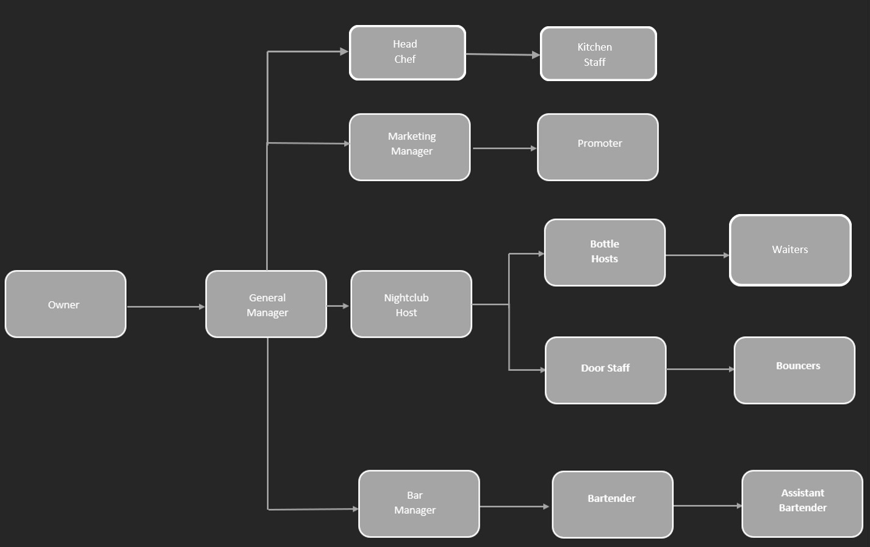

# Define problems and constraints

* Storage space for physical records is limited as to where they can store their books for the current system
* When table bookings are made, some of the booking information is incorrect/misplaced and that results in a conflict with the client.
* Maintaining the current system would be costly for the establishment in terms of time spent entering the data in the books and manually checking which is prone to errors
* The manager can’t keep track of the stock that comes in and out of the business as there are many records to go through, with the different departments that the establishment has.
* Security is a problem. There can be unauthorized personnel getting access to the records or even tamper with them.
* Data redundancy is a great concern when it comes to bookkeeping as copies of the same records are always found in different files and within the irrelevant departments.
* The different departments struggle to communicate with each other due to the current system. This affects the overall performance as the different departments wouldn’t know where they link in terms of the business.

# Database system specification

**Objectives to Solve Problems Identified**

* Create a database that will have enough space to occupy all the attributes to solve the problem and have a computational system to cut costs.
* Database will be implemented in a water tight way to protect the data from unauthorized users.
* Database will be able to supply the manager with the ability to extract reports to keep track of all daily operations.
* Database will allow communication between various departments to be effective with ease with restricted access to the specific department.
* The database restricts the duplication of records.

**Information The Company Requires from The Database**

* 1. The amount of stock in hand
  2. A report on the number of hours worked by the employees.
  3. A report on my suppliers
  4. A Report on sales
  5. A report of all the table bookings and VIP booking.
  6. A Report of all the event bookings
  7. The average number of customers per day, week & month
  8. Calculate turnover profits annually & per quarter

**Scope**

The database will contain data that will assist with the following processes:

* **General Administration** - General administrator will oversee the overall operation of the database, maintenance, suppliers, bar management, personnel resources as well as sales.
* **Maintenance Management** - The maintenance manager will have access to a portion of the database to manage the cleaning product inventory, keep up with suppliers, and keep track of the number of hours the division's personnel put in each week as well as their vacation days.
* **Human Resource Management** - Using their own interface, a human resource manager communicates with the database and has access to manage staff across all departments.

Refer to the above point (information the company requires from the database).

**Boundaries**

* 1. **Finances**: Creating a database and paying for the people involved in the process as well as all the necessary resources is quite costly for an organization like Konka, hence financial support is needed.
  2. **Software**: The new system will only be compatible with Windows 10 and no additional software will be needed to support it.
  3. **Duration/Time**: A five-month schedule is set for the design and implementation of the database.
  4. **Human Resources**: This database will be designed and implemented by five employees within the scheduled five months.

# 

Project Phase 2 – Database Design

# Conceptual Design

## Business rules

* The **customer** has a variety of cuisine and beverages to choose from at which they may be able to order many **products**.
* Each **table** has strictly one **employee** assigned to it but an **employee** can tend to multiple tables or no tables at all.
* A **customer** can make only one **booking/** be assigned to one table only**.**
* Each **booking** is associated with a single **customer**.
* The same **Product** (either alcohol or food) can be ordered by many **customers.**
* A **product (Alcohol/Food)** can be supplied by many **suppliers**.
* A **supplier** can supply many **products.**
* The club employs a large number of people to handle day-to-day tasks. These **employees** can be divided into six primary groups that will be significant while building the database: chefs, waiters, a manager, hostesses, security & bouncers.
* All employee data, including names, surnames, email addresses, and other details, will be transferred from the file system to the database.

## ER Diagram

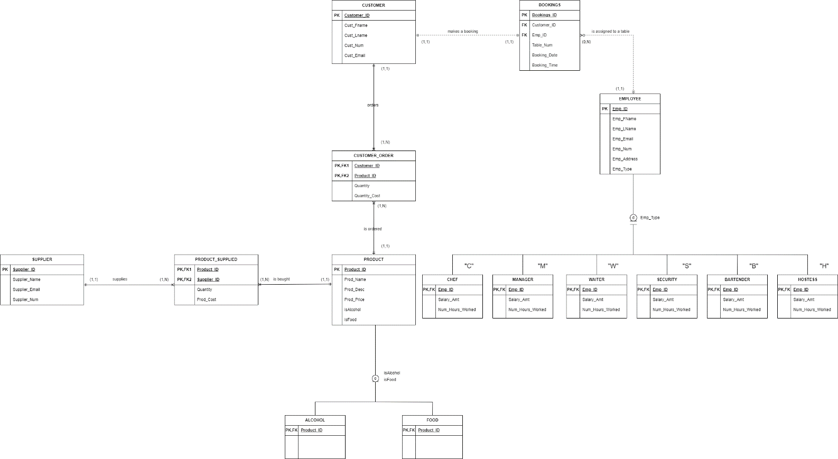

# Logical Design

**CUSTOMER(Customer_ID(PK),** Cust_Fname, Cust_Lname, Cust_Num, Cust_Email**)**

**BOOKINGS(Bookings_ID(PK),** *Customer_ID(FK), Emp_ID(FK),* Table_Num, Booking_Date, Booking_Time**)**

**EMPLOYEE(Emp_ID(PK),** Emp_Fname, Emp_Lname, Emp_Email, Emp_Num, Emp_Address, Emp_Type**)**

**CUSTOMER_ORDER(*Customer_ID(PK,FK), Product_ID(PK,FK),*** Quantity, Order_Cost**)**

**PRODUCT(Product_ID(PK),** Prod_Name, Prod_Desc, Prod_Price, isAlcohol, isFood**)**

**SUPPLIER(Supplier_ID(PK),** Supplier_Name, Supplier_Email, Supplier_Num**)**

**PRODUCT_SUPPLIED (*Product_ID(PK, FK), Supplier_ID(PK, FK),*** Quantity, Prod_Cost**)**

**CHEF (*Emp_ID(PK, FK),*** Salary_Amt, Num_Hours_Worked**)**

**MANAGER (*Emp_ID(PK, FK),*** Salary_Amt, Num_Hours_Worked**)**

**WAITER (*Emp_ID(PK, FK),*** Salary_Amt, Num_Hours_Worked**)**

**SECURITY (*Emp_ID(PK, FK),*** Salary_Amt, Num_Hours_Worked**)**

**BARTENDER (*Emp_ID(PK, FK),*** Salary_Amt, Num_Hours_Worked**)**

**HOSTESS (*Emp_ID(PK, FK),*** Salary_Amt, Num_Hours_Worked**)**

**ISALCOHOL (*Product_ID(PK, FK)*)**

**ISFOOD(*Product_ID(PK, FK)*)**

**Project Phase 3 – Physical Design**

# Database Objects

## Tables

The following Create Table statements will be in context of tables and their attributes that allow for the organization and management of customers, bookings, employees, orders, products, suppliers, as well as employee roles within the establishment, Konka. The relationships between the tables enable data integrity and provide a foundation for querying and analysing the data effectively. The primary and foreign keys will receive the Number data type as the maximum field size to be indicated using brackets. Any deviations from these standards are then discussed in detailed in the respective sections below.

**CUSTOMER Table**

This table would essentially store information about the customers. It consists of the following attributes:

The Customer_ID attribute serves as the primary key of the table and is used to uniquely identify each customer within the database. This attribute can only accommodate up to 4 digits. The Cust_Fname attribute represents the first name of the customer. The Cust_Lname attribute represents the last name of the customer. Cust_Num stores the contact number of the customer. The Cust_Email attribute stores the email address of the customer.

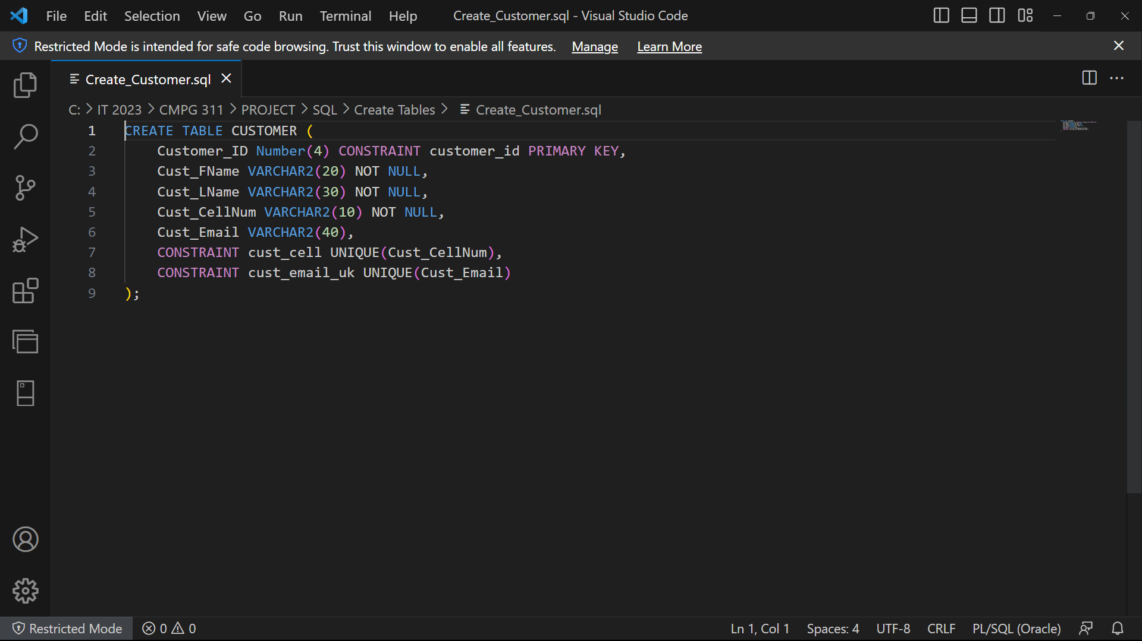

**BOOKINGS Table**

This table stores information about bookings made by customers. It includes the following attributes:

The Bookings_ID attribute serves as the primary key of the table and is used to uniquely identify each booking made by the customer. The Customer_ID attribute is a foreign key referencing the Customer_ID in the CUSTOMER table, establishing a relationship between a booking and the corresponding customer. Emp_ID is also a foreign key referencing the Emp_ID in the EMPLOYEE table, establishing a relationship between a booking and the employee assigned to it. Table_Num represents the table number associated with the booking. The Booking_Date attribute stores the date of the booking that has been made. Booking_Time attribute stores the timestamp of the booking, capturing the date and time of the booking.

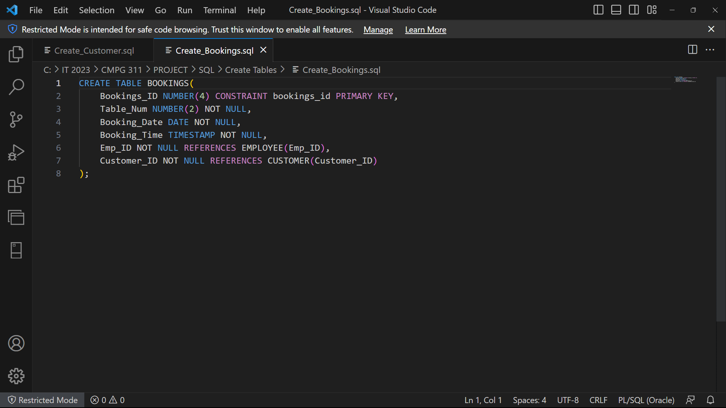

**EMPLOYEE Table**

This table stores information about employees working at Konka. It includes the following attributes:

The Emp_ID attribute serves as the primary key of the table and is used to uniquely identify each employee working at the establishment. Emp_Fname represents the first name of the employee. The Emp_Lname attribute represents the last name of the employee. Emp_Email stores the email address of the employee. The Emp_Num attribute stores the contact number of the employee which can take up 10 characters. The Emp_Address attribute represents the address of the employee. Emp_Type specifies the type or role of the employee, such as chef, manager, waiter, security, bartender, or hostess within the establishment.

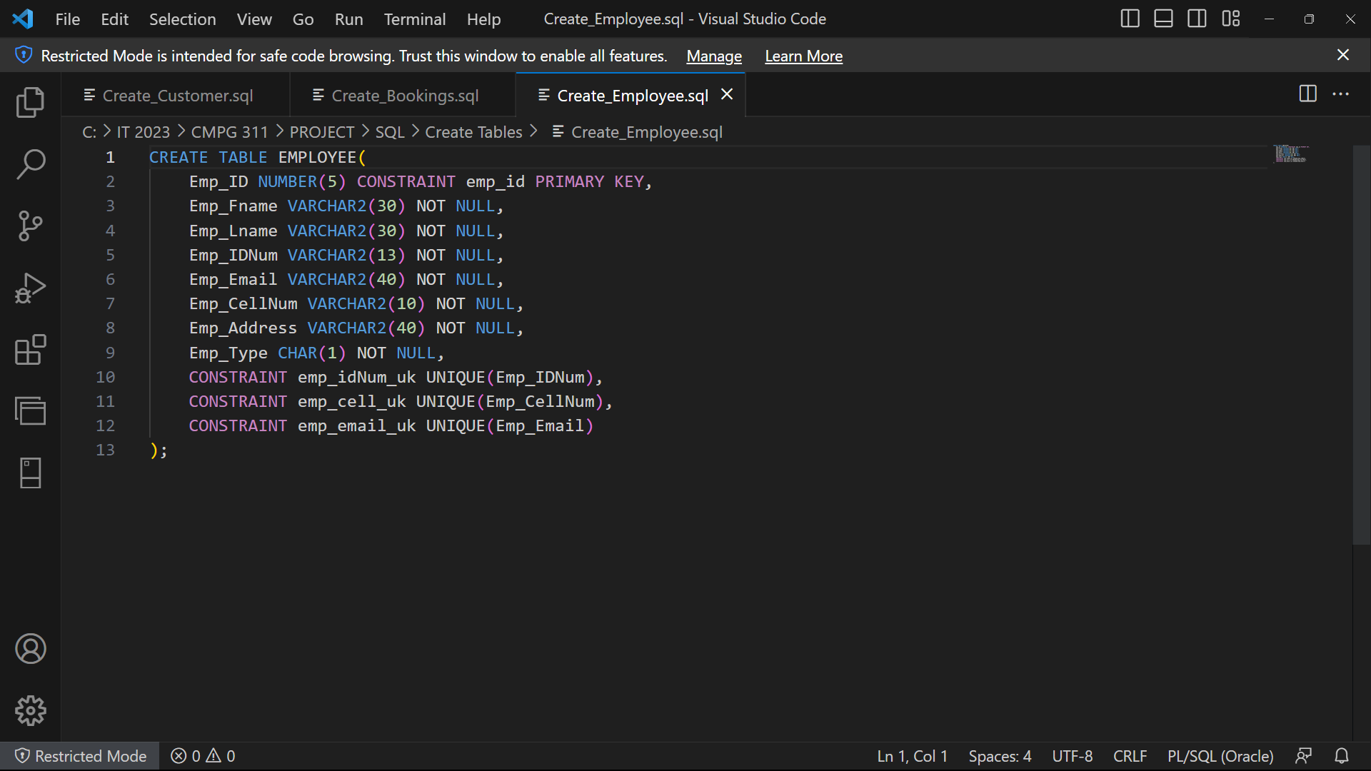

**CUSTOMER ORDER Table:**

This table stores information about customer orders that are taken at the establishment. It includes the following attributes:

The Customer_ID attribute serves as both the primary key and a foreign key referencing the Customer_ID in the CUSTOMER table, establishing a relationship between an order and the corresponding customer. Product_ID serves as both the primary key and a foreign key referencing the Product_ID in the PRODUCT table, establishing a relationship between an order and the ordered product. The Quantity attribute stores the quantity of the product ordered at the establishment. Order_Cost stores the total cost of the order.

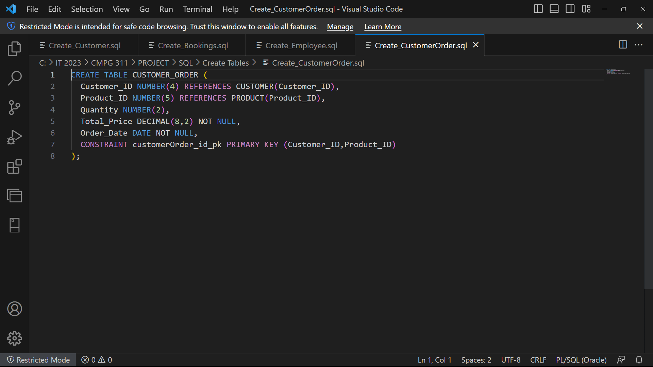

**PRODUCT Table:**

This table stores information about products available for purchase. It includes the following attributes:

The Product_ID attribute serves as the primary key of the table and is used to uniquely identify each product available to be purchased at Konka. Prod_Name represents the name of the product. The Prod_Desc attribute provides a description of the product. Prod_Price attribute stores the price of the product.

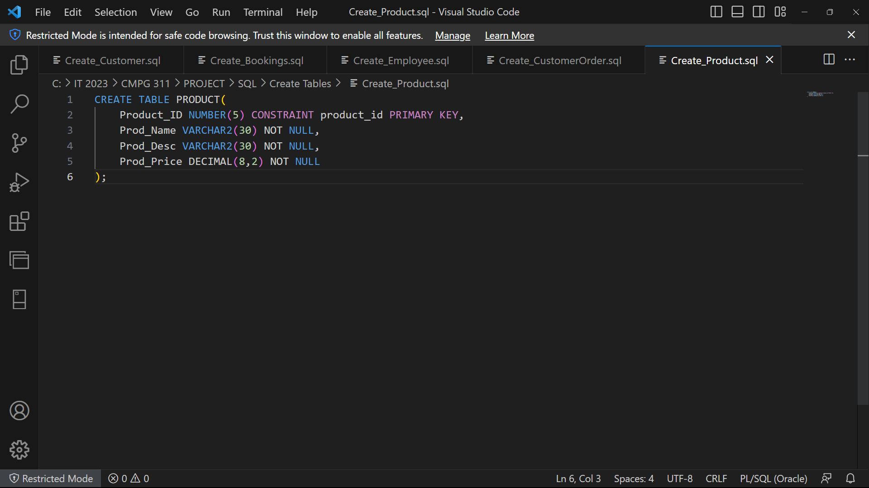

**SUPPLIER Table:**

This table stores information about product suppliers. It includes the following attributes

The Supplier_ID attribute serves as the primary key of the table and is used to uniquely identify each supplier for the establishment. Supplier_Name represents the name of the respective supplier. The Supplier_Email attribute stores the email address of the supplier. Supplier_Num stores the contact number of the supplier.

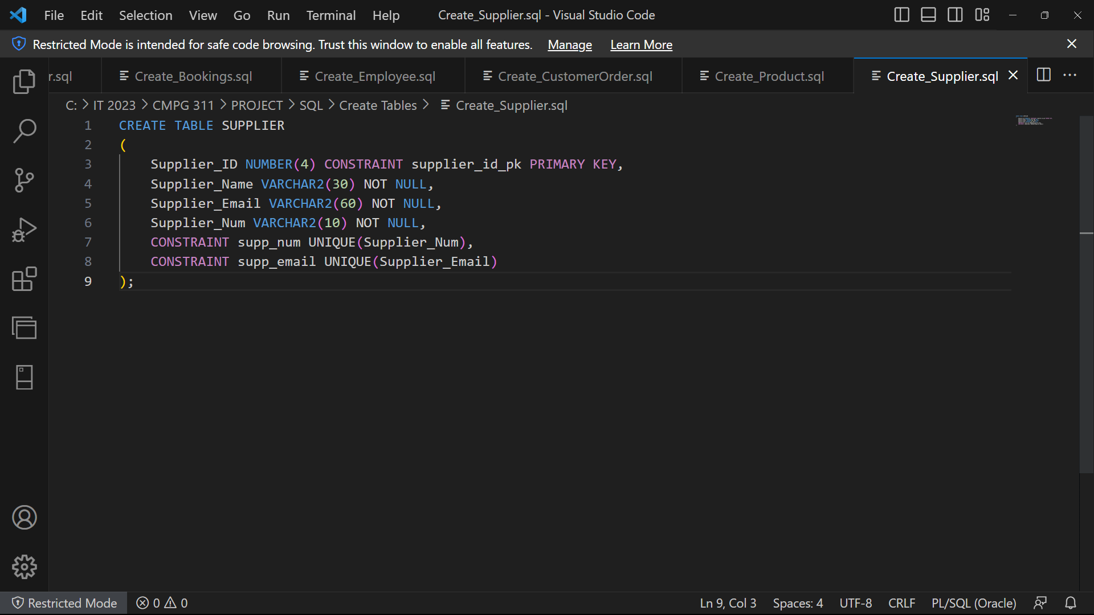

**PRODUCT SUPPLIED Table:**

This table represents the relationship between products and suppliers, as it stores information about which products are supplied by which suppliers. It includes the following attributes:

The Product_ID attribute serves as both the primary key and a foreign key referencing the Product_ID in the PRODUCT table, establishing a relationship between a product and the supplier supplying it. Supplier_ID serves as both the primary key and a foreign key referencing the Supplier_ID in the SUPPLIER table, establishing a relationship between a supplier and the supplied product. The Quantity attribute stores the quantity of the product supplied by the supplier. Prod_Cost stores the cost of the product supplied by the supplier.

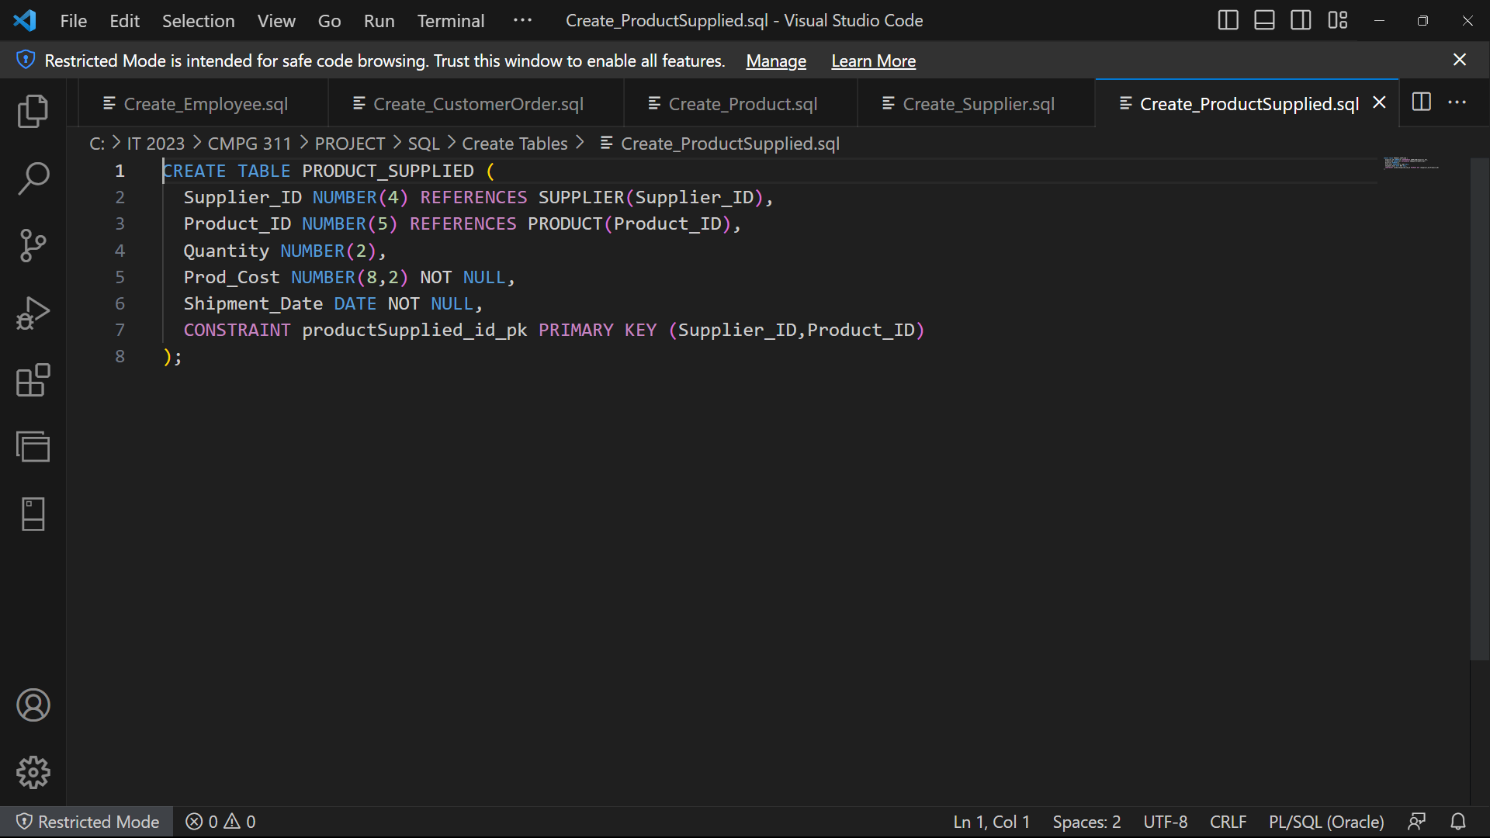

## Indexes

## Views

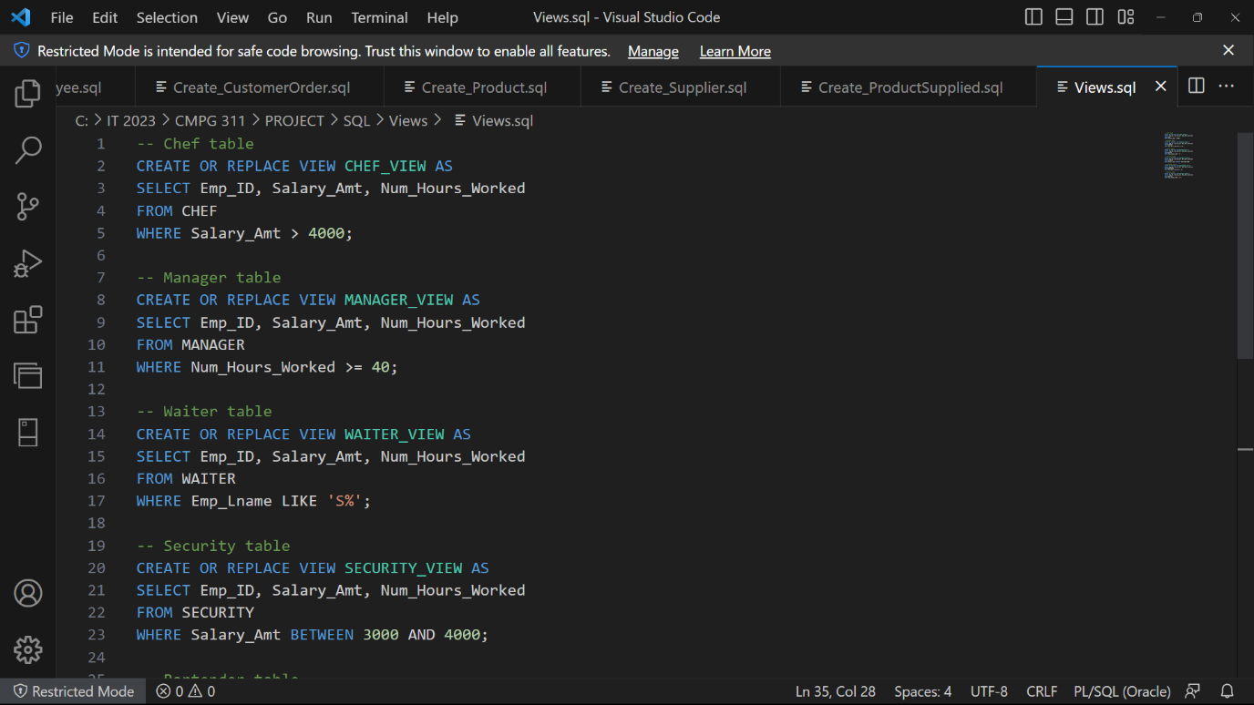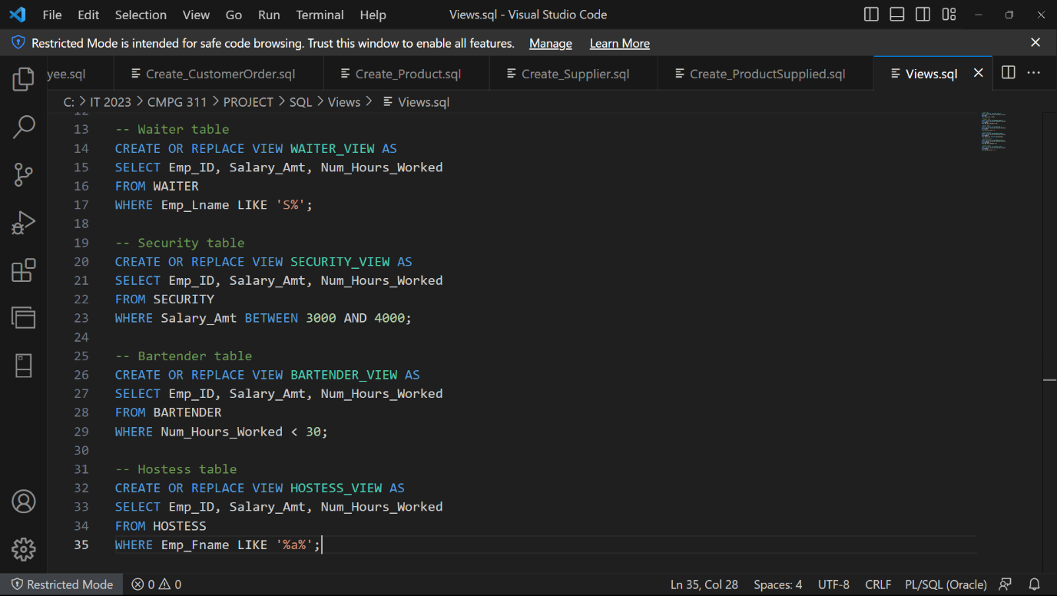

## Data loading

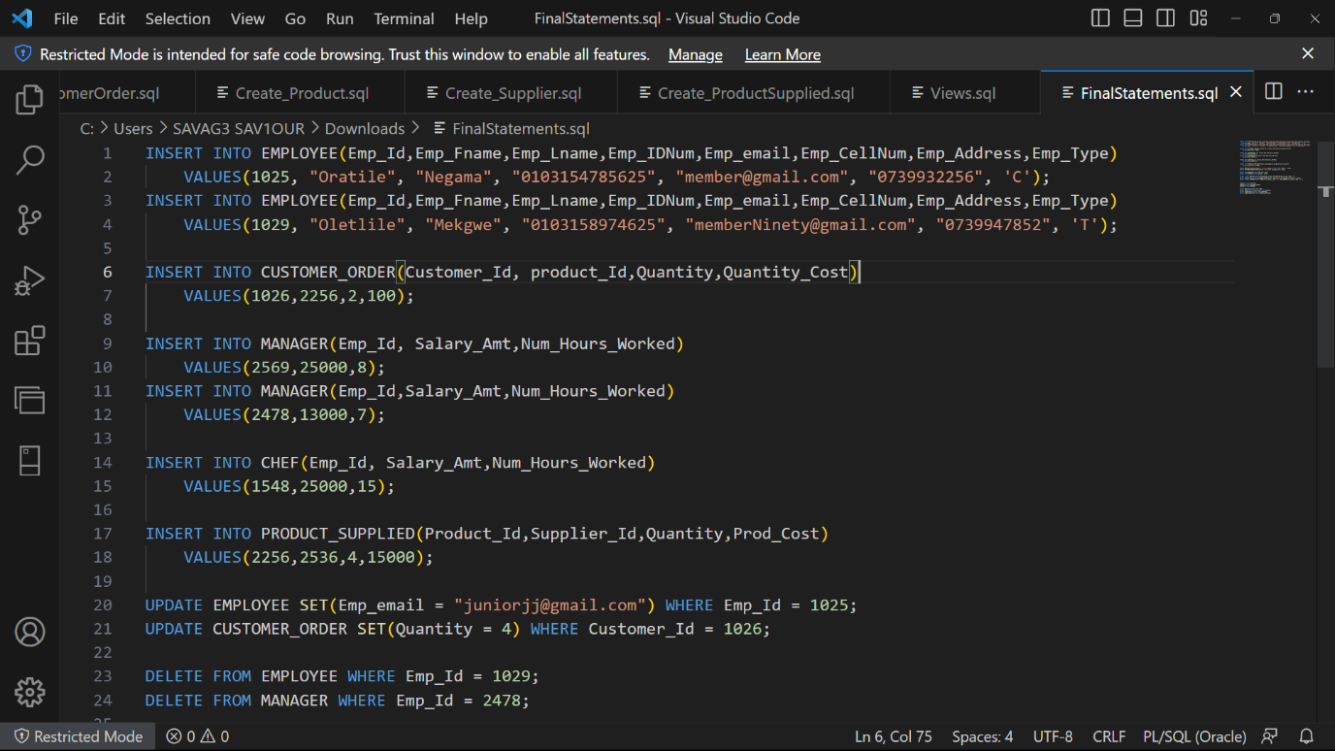

# Queries

## Limitation of rows and columns

## Sorting

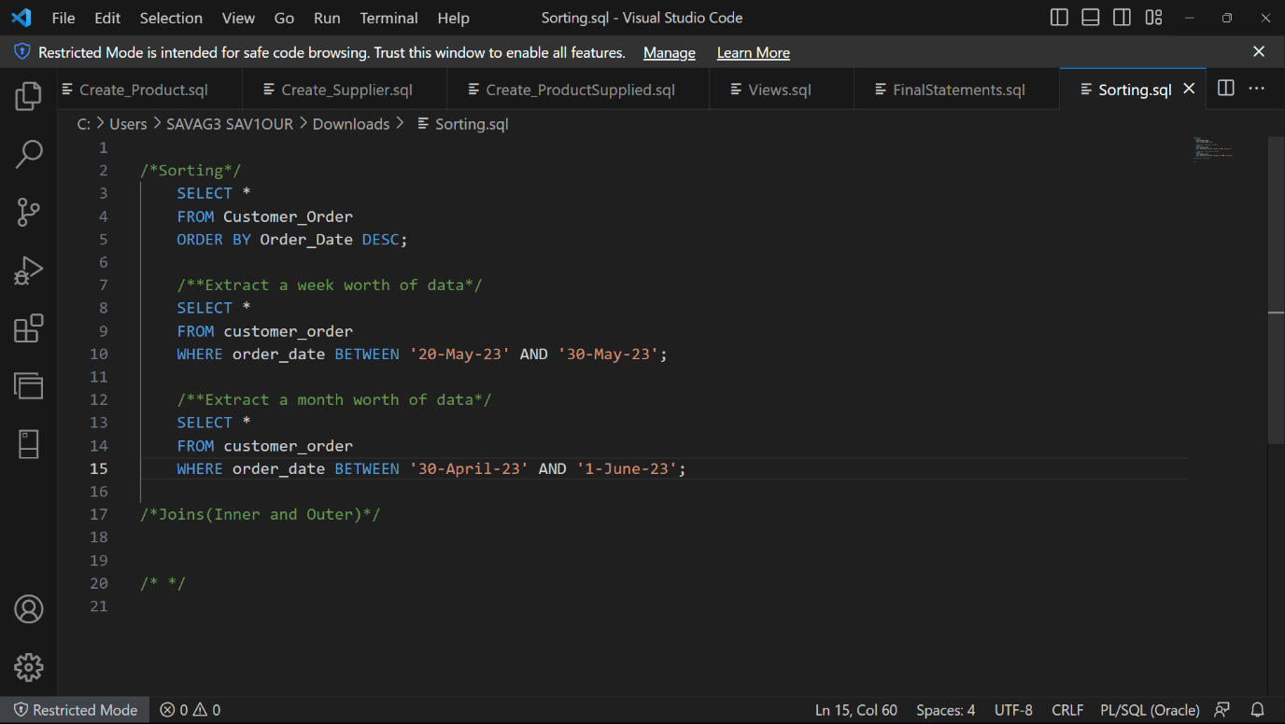

## LIKE, AND and OR

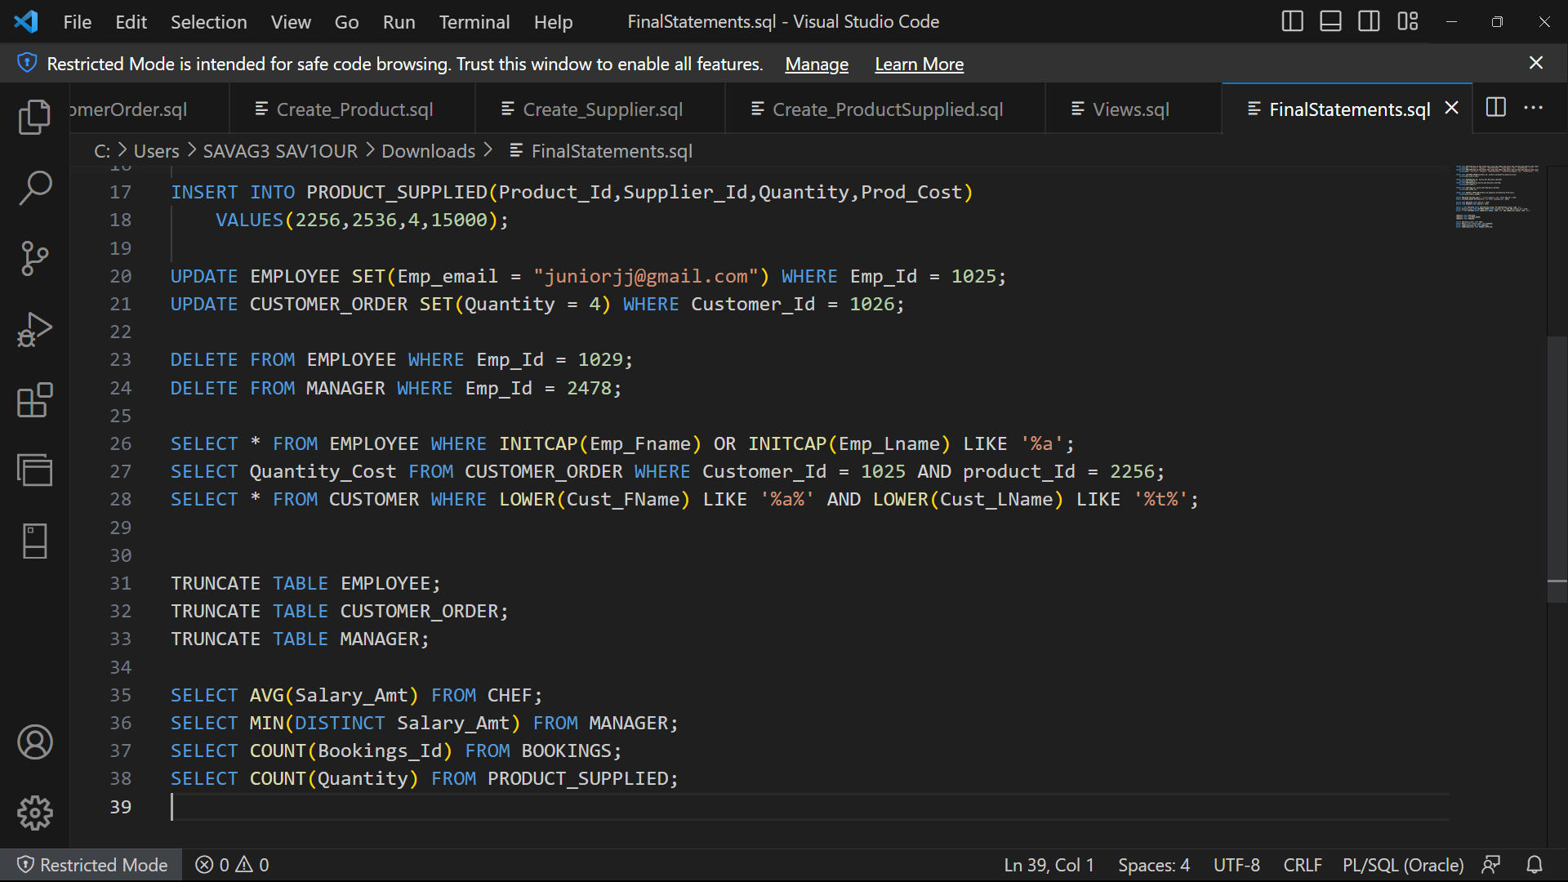

## Variables and character functions

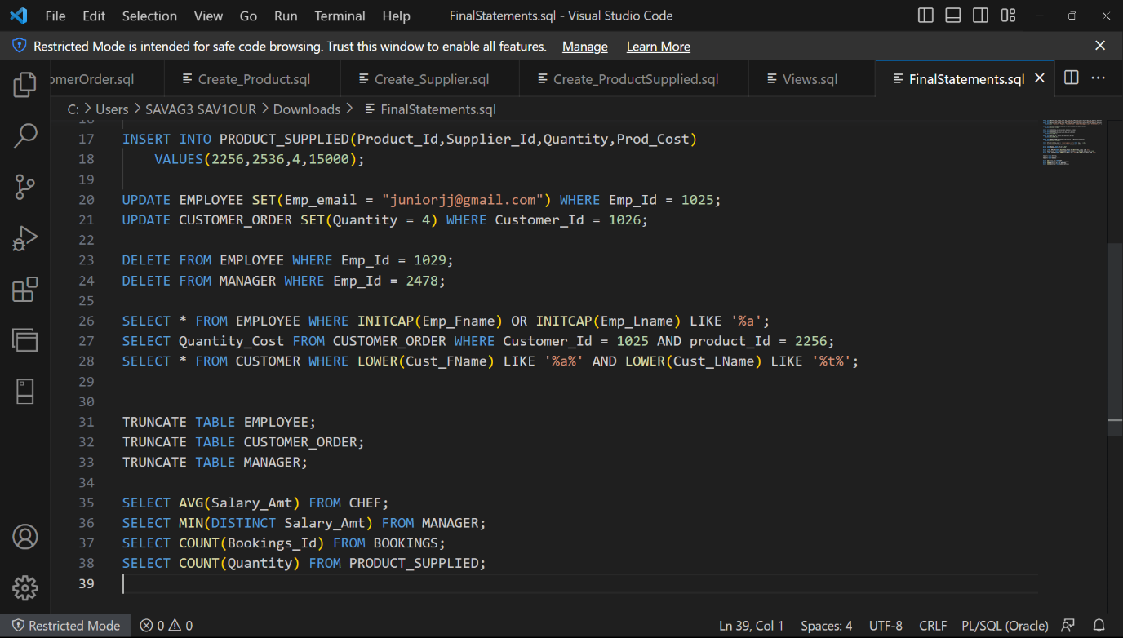

## Round and/or trunc

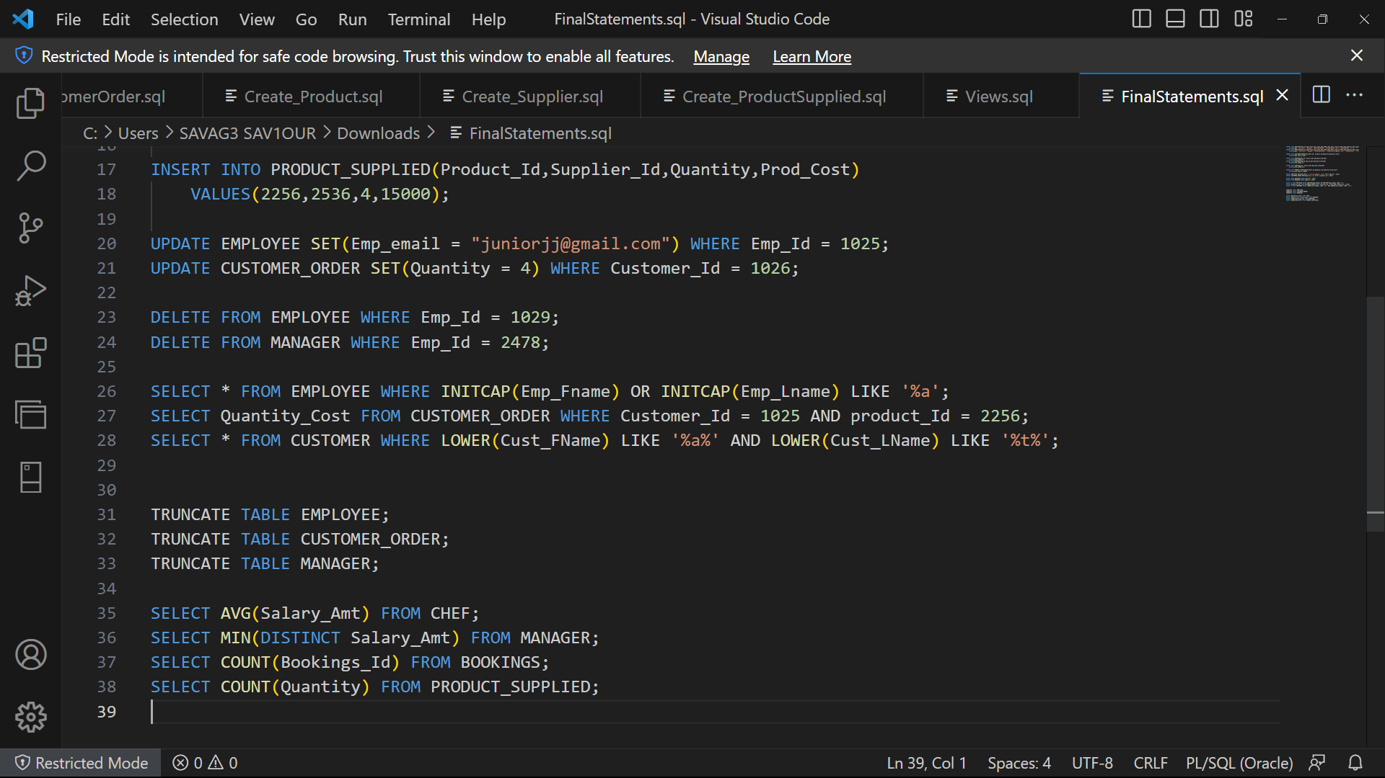

## Date functions

## Aggregate functions



## Group by and having

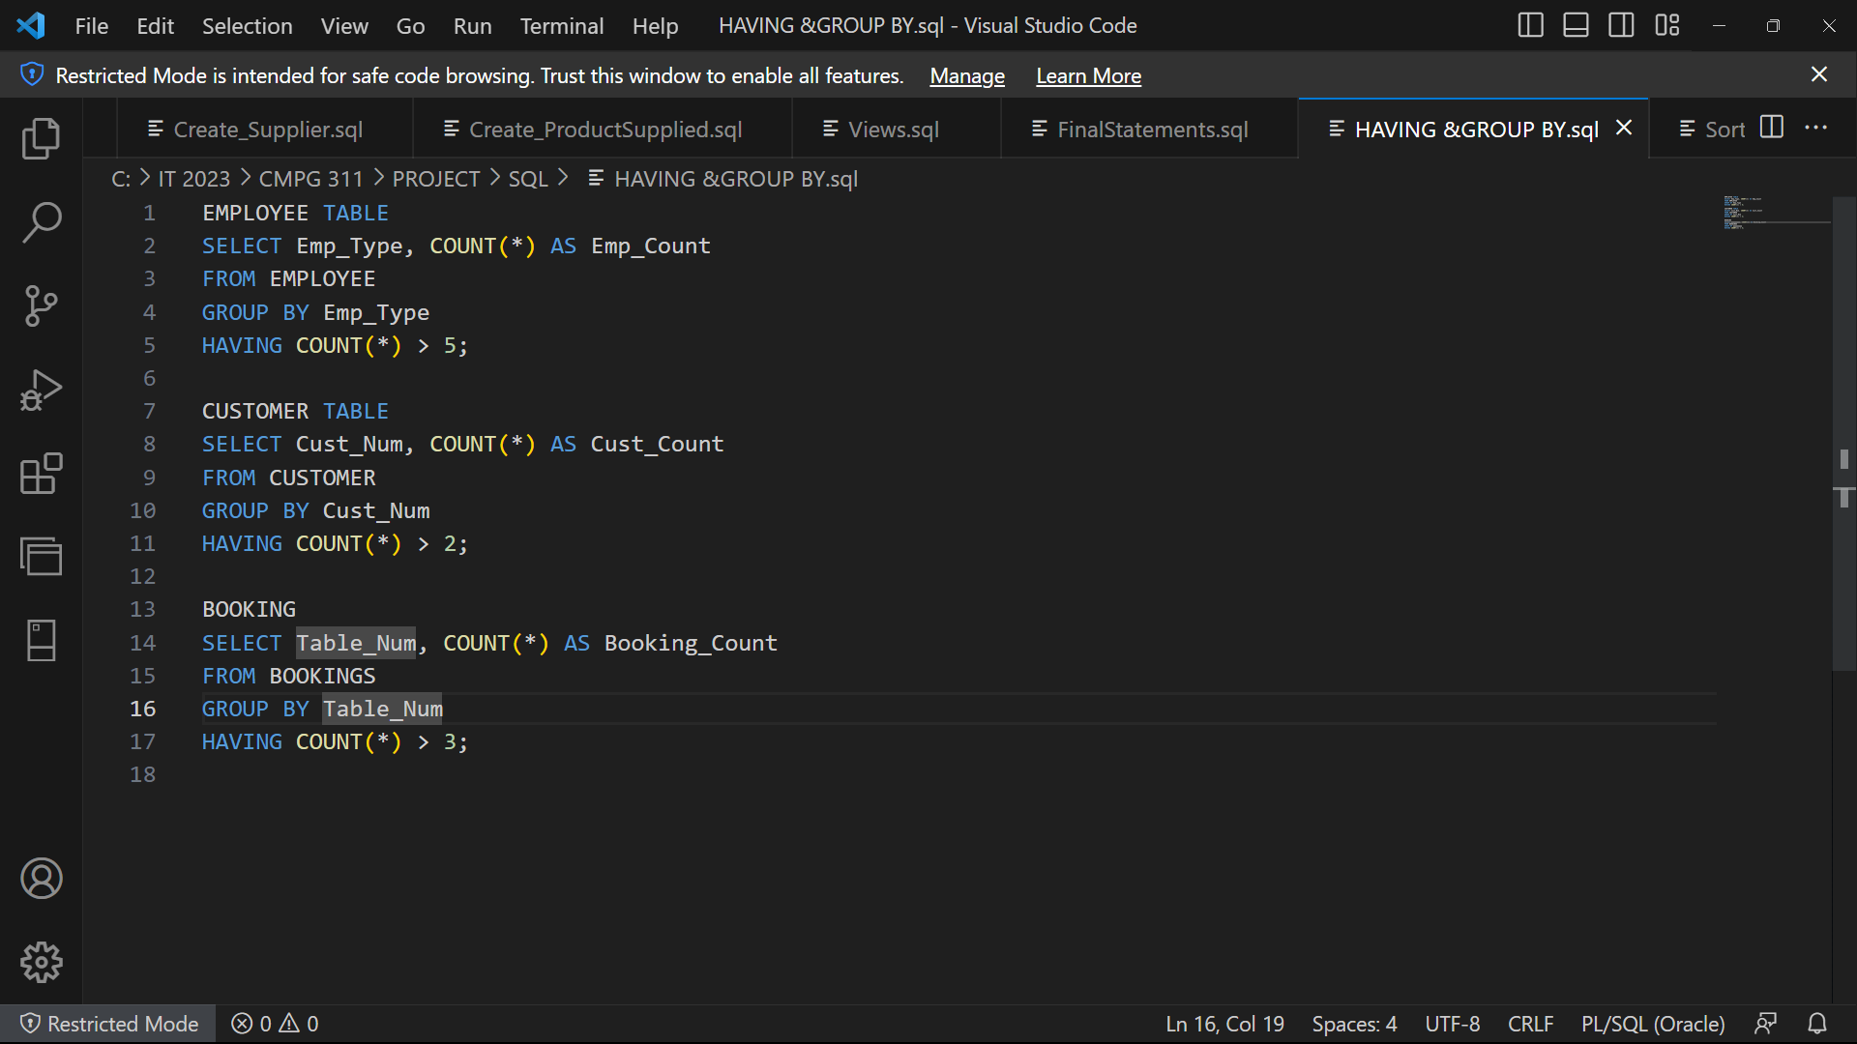

## Joins

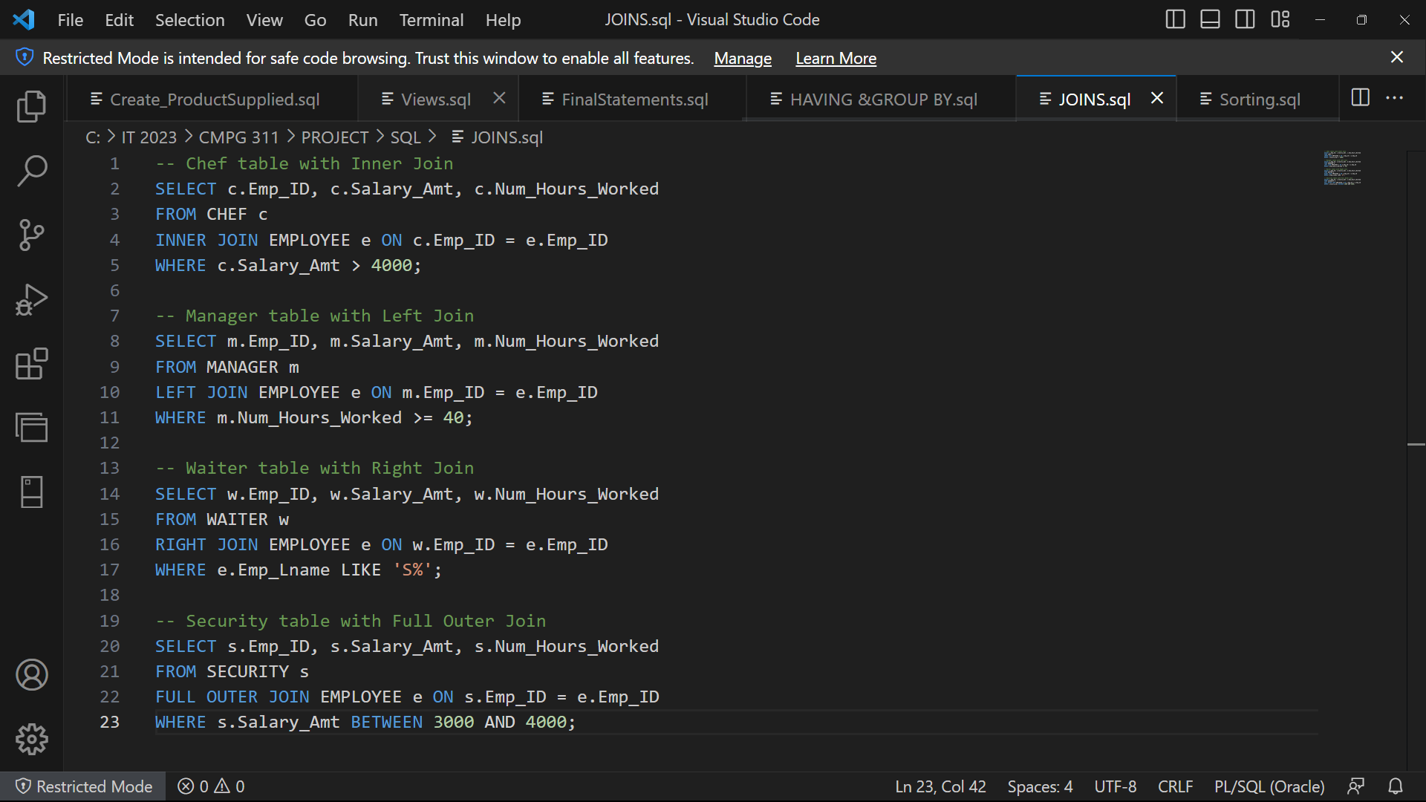

## Sub-queries

